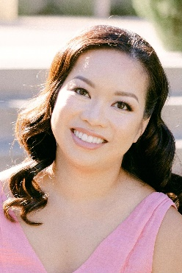
Megen Vo, Soprano
(518) 221-8601 · Megen.vo@gmail.com
Range: F3 to D6

Opera/Operetta Experience
Production | Role | Company | Conductor | Director
The Red Mill | Tina | Lyric Theatre San Jose | Michael Taylor | Michael Taylor
Ruddygore | Ensemble | Lamplighters | Baker Peeples | David Euresti
Madama Butterfly | Cousin | West Bay Opera | José Luis Moscovich | Richard Harrell

Concert Experience
Broadway by the Decade (South Bay Musical Theatre, music director Brad Handshy) February 2025
Soloist
Cole Porter Celebration Concert (Lyric Theatre San Jose, conductor Michael Taylor) July-August 2024
Soloist

Awards
First Place, Advanced Category, Cal-Western NATS Musical Theater Student Auditions January 2024
First Place, Advanced Category, Cal-Western NATS Classical Student Auditions January 2024
First Place, Musical Theater, Arizona International Music Competition December 2023
Second Place, Classical, Arizona International Music Competition December 2023
Second Place, Advanced Category, SF Bay Area NATS Musical Theater Student Auditions November 2023
Second Place, Advanced Category, SF Bay Area NATS Classical Student Auditions March 2023
Honorable Mention, Advanced Category, SF Bay Area NATS Musical Theater Student Auditions November 2022

Training and Education
Case Western Reserve University – Bachelor of Arts in voice, psychology
University of Rochester School of Medicine – Doctor of Medicine
Voice teachers and coaches: Erin McOmber (current), Julia Nielsen (current), Amy Heumann (current), Ron Valentino, Benjamin Liupaogo, Russell Norman
Additional skills: fluent in Spanish, proficient at violin, basic piano, practicing Pediatrician

